Week In Review
Alex Shvartsman

THE WEEKEND OF CHAMPIONSHIPS - FIRES DOMINATES
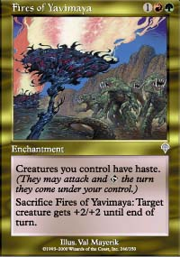
Fires of Yavimaya dominated the U.S. Nationals despite most of the field metagaming heavily against this deck. PTLA winner Trevor Blackwell is the new U.S. National Champion, having swept team ABU's Brian Hegstad and his white-blue control deck in the finals. They are joined on the U.S. National Team by CMU affiliate Eugene Harvey. David Bachmann qualified for Worlds by taking fourth place. The U.S. National team isn't very high profile this year, but they should be quite competitive at Worlds nevertheless.
The real hero of the day was Head Judge Collin Jackson, who came down hard on one of the greatest problems currently facing high-level competitive Magic - stalling. Multiple warnings for stalling were issued over the weekend, culminating in a game loss awarded to Peter Leiher in the last round of Swiss, which allowed his opponent Brian Hegstad to make the Top 8. Jackson felt that Leiher was playing too slowly in a situation where he could not possibly win the game. Jackson struck again during the Top 8, disqualifying Casey McCarrel during his quarterfinal match. Jackson and other judges believe that McCarrel was intentionally stacking his opponent's deck while shuffling it. McCarrel, who already had trouble with the DCI, receiving a six month sentence after misrepresenting a match result to a judge at Pro Tour:-London, might not be coming back to competitive Magic for some time.

A big deal has been made of Mike Long not attending this year's Nationals (he wasn't qualified). However, Long had an influence on another important National Championship - Matsuo Goro played Mike Long's Fires build to a first place finish, becoming Japanese National Champion. He beat a black-red "Machine Head" deck in the finals, played by Kim Min-Su. They are joined on the National team by Morita Masahiko, who played a red-green deck without Fires of Yavimaya, appropriately named "No Fires" - spoofing off the "No Hermit" deck from a year ago.
Fires won in Portugal too, making Dinis Maia the new National Champion. He defeated a w-g-r deck designed by German nationals finalist Stephan Valkyser and played by one of the best-known Portuguese players, Helder Coelho.
One country where Fires were fought off was the Netherlands. Home to many of this year's emerging stars - Cornelissen, Fuller, Boeken, Snepvangers - none of these made the National Team. Fuller and Boeken finished in the Top 8, but failed to advance. Tom van de Logt - an experienced pro player, but without a resume as impressive as those listed above - became the National champion, playing a blue control deck with a splash of black for Tsabo's Decree - similar to that designed by Brian Kibler for US Nationals. Jeroen Remie came in second playing - you guessed it - Fires. Frank Karsten made the team by coming in third with a Probe-Go deck, and Wessel Oomens qualified for Worlds with a Sligh deck.
At the Junior Super Series Championship, Ben Ashkar navigated his Fires variant (splashing black) to victory, defeating Ralph Trapas's Opposition-Orb Merfolk deck in the finals. The diverse field of decks ranging from carbon copies of some of the best decks at the U.S. Nationals taking place just a few feet away, to some very original designs, shows that this tournament is worth paying attention to.

DCI TOURNAMENT POLICY UPDATE

DCI tournament policy for the upcoming 2001-2002 season has been published here this week. There are several significant changes that pros and aspiring pros should be aware of.
First of all, it is now slightly harder to obtain byes at Grand Prix based on Pro Tour points. It now takes seven points for one bye (as opposed to five), fourteen points for two (as opposed to 12) and 28 points for three (as opposed to 24). Pro points will become slightly easier to come by though - every player attending a team Pro Tour will now receive two points instead of one. All players competing as a part of National teams at the World Championships will also receive Pro points. While Grand Prix thresholds had been raised, it still takes the same number of points to qualify for the Tour - twenty.
Several of the policies that are already being used have been written into the new policy book. For example, the way Amateur prize money are distributed at Grand Prix. Previously, amateur player status was tracked based on the DCI rating. It was a difficult and time-consuming system, where players often did not know whether they were eligible for the prize themselves. Under the new (and current) system, any player who has zero Pro points lifetime is eligible for the Amateur prize - as simple as that.
There are a number of other changes relevant to players planning to compete in National Championships, Grand Prix and other various high profile events. If this information may affect you, take fifteen minutes to familiarize yourself with this document.

MAGIC TRIVIA
Last week's question:
What pro player managed to come in 1st, 9th and 10th in 3 US National Championships in a row?
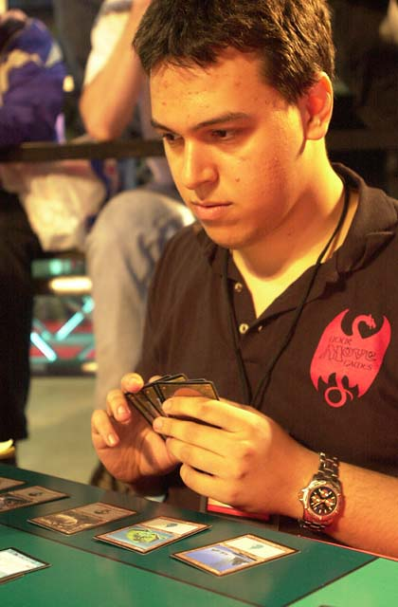
It was Justin Gary. Actually, he skipped a year - he won Nationals in 1997, then came in 9th in '99 and 10th in '00. Gary did not finish in the money this year, but I am not counting him out for 2002 Nats.
New question:
Who is the only person to attend every Pro Tour to date? (hint, he is not a player)
Please do not e-mail me your answers. The correct answer will be posted in next week's column.

PLAY OF THE WEEK
Adrian Sayers was playing against Mike Pustilnik in the last round of U.S. Nationals. The winner would finish in the money.
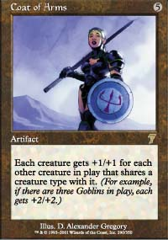
In the third game Pustilnik opened with Birds of Paradise, then played Yavimaya Barbarian and started sending it in. Sayers played nothing until turn four, when he cast Spontaneous Generation, making six 1/1 Saprolings. Pustilnik, who had no mass removal to take them out, attacked with the Barbarian, but Sayers chose to take two damage rather than block. Pustilnik tapped out to summon Shivan Wurm and Llanowar Elves.
On his turn, Sayers played land number five, cast Coat of Arms and attacked for thirty six! Pustilnik could block two Saprolings, but he would still take twenty-four points of damage. Pustilnik kept reading Coat of Arms and trying to find a flaw in Sayers's plan, but there was none to be found.
As always, please send good/bad plays, cool trivia questions, and other news to ashv@concentric.net.

